Module Code : CS1HW22

Assignment Title: Website development

Date (when the work completed): 18/03/24.

Actual hrs. spent for the assignment: 26.

Link of your solution: Zip attached.

|  |  |  |
| --- | --- | --- |
| Name | Sections | Signature |
| Omar Azam | Equal Contribution | Omar Azam |
| Santi Balbuena Goni | Equal Contribution | Santi Balbuena Goni |
| Eesaa Mahmood | Equal Contribution | Eesaa Mahmood |
| Daniel Rice | Equal Contribution | Daniel Rice |
| Sukhveer Sidhu | Equal Contribution | Sukhveer Sidhu |

Introduction: 3

Homepage design: 3

HTML: 3

Index.html 3

Shop.html 4

Shopping Cart: 4

Cart.html: 5

Contact.html 5

About.html: 5

Shop.html CSS 7

About.html CSS 8

Contact.html CSS 8

Cart.html CSS 8

CSS Conclusion 8

Graphics 9

SVG Logo 9

Use of JPEG 9

JavaScript 9

Interactive Features: 9

Show Offer Homepage 9

Browser Object Model (BOM) and Document Object Model (DOM) 10

Conclusion and future works: 11

References 12

# Introduction:

Our company, StepUP, is a shoe retailer which only sources and sells shoes that are environmentally friendly and ethically sourced, since unfortunately many popular shoe retailers sell shoes created with materials extracted from poorer parts of the world. The purpose of creating this website is to allow us to provide a fast and efficient means for our customers to purchase shoes as compared to them needing to visit our stores in person. This website will also enable us to build a brand identity allowing us to compete with other shoe retailers who aren’t as ethical as StepUP and to give our customers confidence in our products, because if our website is engaging and professional they are more likely to purchase from us. We will also be able to scale our business by generating greater reach via our website.

Our knowledge of HCI will enable us to create this website, as we have learnt many of the steps involved in creating a website, and how to create a website that is to an acceptable and professional standard. For example, through an interface which is pleasant, has a low cognitive load, and is easy to use. Our target audience are those who are environmentally conscious. The typical age of our users would be around 16-40 so we need to tailor our website so that it’s engaging. Some key features of our website include an engaging homepage with a hero banner to capture the viewers' attention, the implementation of features which allow our customers to shop. Through allowing them to add remove and view their shopping cart, an about page clearly outlining the objectives and aims of our company, and a contact page allowing customers to dispute or discuss any issues with our storefront.

# Homepage design:

The homepage design is engaging as it offers a clear navigation bar for the users, the hero banner which contains a trainer clearly outlines the purpose of the website and the product that we sell. When the user first visits our homepage they will notice that our logo is centred allowing it to stand out. We also clearly display the name of our brand/company “StepUP”. The hero banner also immediately captures the customers attention when they visit our website.

The same layout for the navigation bar and buttons on each page ensures consistency on all our pages, which also provide confidence to our users as our websites have a consistent layout. The three featured images underneath the hero banner also aim to entice the user with new products that we are currently selling which increases user interest in the page, the featured images all have a consistent white background allowing the shoes to contrast with the background. Underneath each featured image we allow the user interactivity allowing them to navigate to the shop page this retains and encourages user retention.

# HTML:

Note, once we perfected the navigation bar, this was duplicated for all pages. This helps to ensure consistency and familiarity across the website, in conjunction with the same single stylesheet being used across all pages.

## Index.html

This HTML code contains a promotional banner for our homepage which informs the user of the code they can use for the discount. There is also a hero banner here which will engage users when they visit the homepage, and we have included a call-to-action button to take the users to the “shop.html” page. The “featured section” contains 3 images of shoes which aim to entice the user along with a description of which shoe collection they’re part of. These three images all link to the shop page allowing the user to purchase the shoes. The logo has also been centred so that it stands out more when the customers visit the page.

## 

## Shop.html

**Shopping cart section:** The area containing the shopping cart is contained in a with the class “cart”. It contains two links: one that encircles the text “Shopping Cart” and the other that encircles an image of a cart icon. Users are sent to “cart.html” via both links. The image link is stylised with inline CSS to take use of a flexbox layout, centring the icon both vertically and horizontally, and adding an eye-catching inverted colour effect.

**Product Items:** the class “items” houses the product items section, which displays several distinct product containers with the name "product" on them. Every product container has a picture of the shoe product and a headline that describes it and says what kind of shoe it is. The pricing details are given below, which include the discounted price as well as the original price with a strike-through effect and the percentage of the discount. Finally, a "Add to Cart" button with the class "product_button" and a data-id field that is used for product identification enables users to add the item to their shopping cart.

## Shopping Cart:

Users can view the products they currently have in their shopping basket below the header. Along with a box to enter coupon codes to apply discounts, the entire cost of the products in the cart is shown. Using the same buttons, users may also proceed to checkout or remove items from their cart.

## Cart.html:

Once customers have browsed and added to their card from our selection of shoes on our website's Shop Page. They can go to the Cart.html page, wherein the item names are displayed along with their quantity, pricing, and pictures. Here, the customer is also able to enter a voucher code – advertised on the home page: 20OFF – and have (another) 20% taken off their order.

**Header and Navigation:**

Following previous pages, the header and all links are consistent.

## Contact.html

The Contact Page has the navbar and header as the other pages, but also contains a form which inputs for name, email, message, and a submit button in order to send feedback or report a concern with the page or an order.

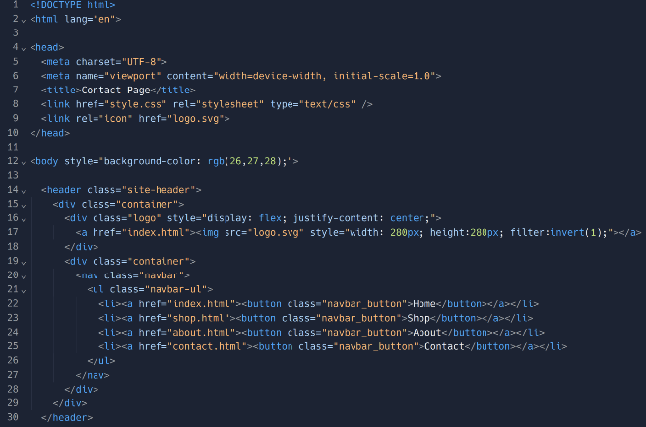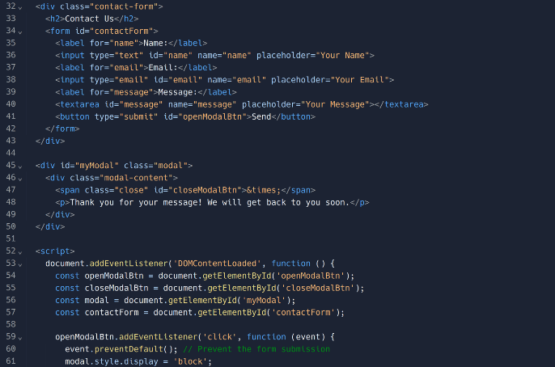The "Contact Page" webpage's structure is set by this HTML code. Standard document declarations are made first, and English is selected as the document language. Essential metadata like character encoding, viewport settings, the page title, and references to external resources like a favicon and a CSS stylesheet for styling are all included in the element. The page's content is defined by the body> section, which also includes a header section with a navigation bar and a logo. The navigation bar is made up of buttons that go to other pages, and the logo is a clickable link that takes users to the homepage, which displays an image. The logo is stylized with certain dimensions and an inverted colour effect, while the general layout is made with a dark grey backdrop colour.

## About.html:

Our website's "About" page gives visitors information about our values and identity. It acts as a channel for sharing with our audience the goals and core values of our brand.

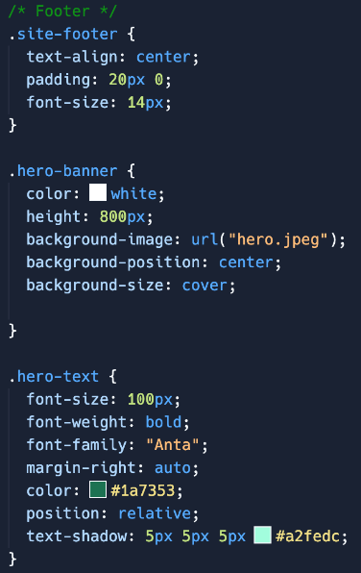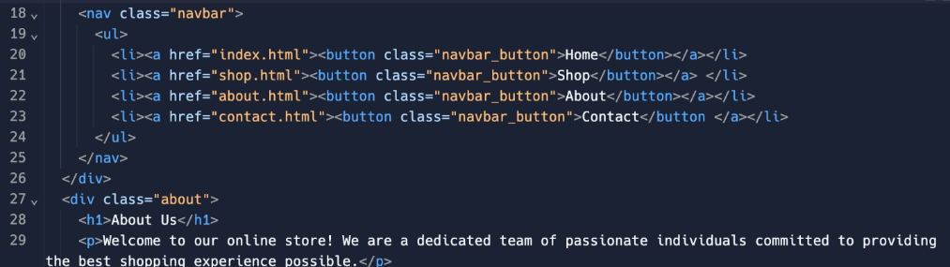**Header and Navigation:** Our logo, which represents our brand identity, is shown in the header section. Users can easily browse between the Home, Shop, About, and Contact pages of our website by using the navigation menu. “About Us," a powerful header that draws the reader's attention right away, introduces the major information of the About Page. We extend a hearty welcome to our online store beneath the banner, stressing our commitment to providing the greatest possible purchasing experience.

This HTML code snippet defines a navigation bar with buttons that are encased in anchor elements and uses the href property to link to different pages. For later use in CSS, the class property of the buttons is set to "navbar_button", so we can change style attributes of the navbar and have it reflected everywhere on the webpage. The webpage's "About Us" section is comprised of a class "about". It encloses a heading and a paragraph where we explain our goal of the website.  
CSS; Index.html CSS  
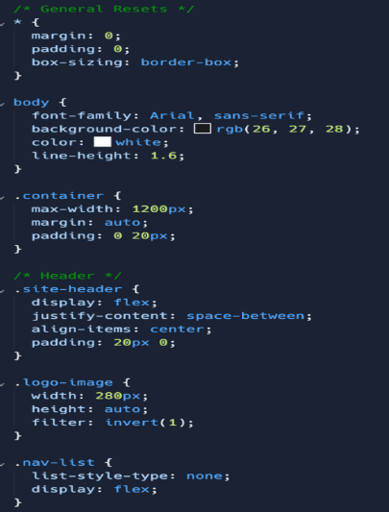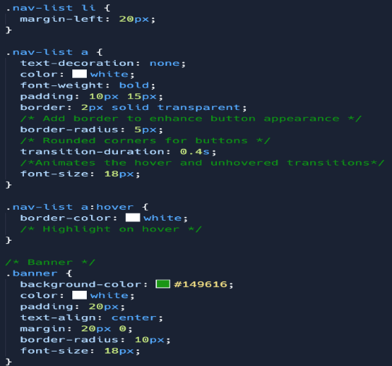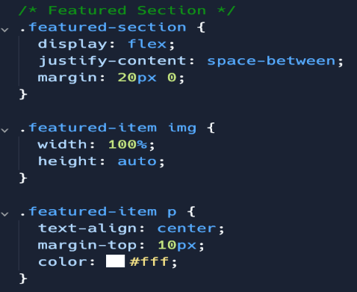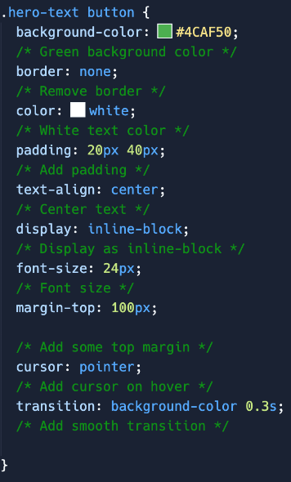This code is used for the positioning of the logo, site name, and navigation buttons that is used across all of our pages. It sets a default font setting for body to keep all the text the same unless otherwise specified. The nav buttons are styled here and made to fade into the background and not be distracting but usable when needed. They have a hover feature that adds a white border when hovered to let the user know when they are hovering over each button. The text on the hero banner uses a custom font “Anta” that stands out compared to other fonts, and is pleasing to look at, especially when combined with the background image that gives the user a sense of interest/fascination.

The rest of the website has bright colours to contrast with the darker background that makes everything stand out. It also has text on top of the background hero banner styled in a way that makes it stand out, but also fit in. At the button there are images and buttons of products that take the user to the shop page. This is a simple intro page (home page) that effectively shows the user what StepUP has on offer, ensuring all elements have enough space to stand out to the user and be readable.

## Shop.html CSS

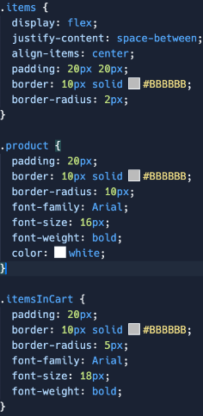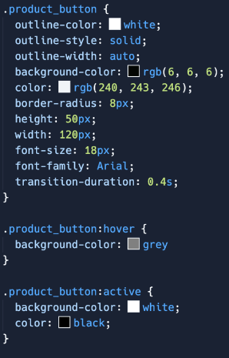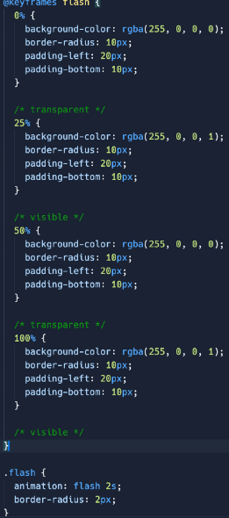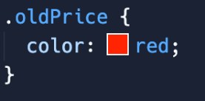

This CSS gives the website the table borders and button colours for the product add to cart buttons, as well as the hover on add to basket buttons to show feedback to users. It also has the animation for the red effect when an item is added to basket.

## About.html CSS

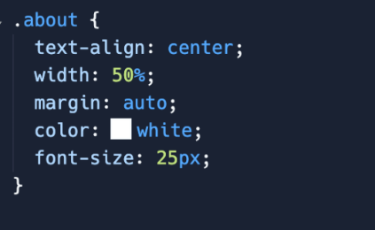  
This code is used to style the about page, making text bigger and centered as it is the main focus of this page. The nav bar and site logo is the same as index.html.

## Contact.html CSS

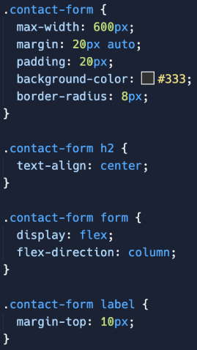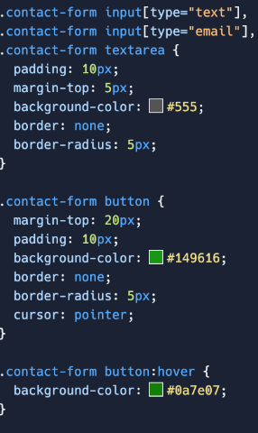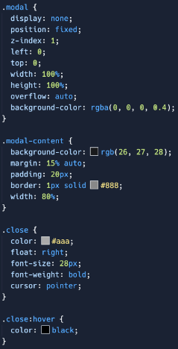

This code is used to create the contact table in the contact page, giving it the colour size, margins, aligning the text to the middle to fit with the style. It also changes the labels, input fields, and send button. It makes the table stand out against the darker background.

## Cart.html CSS

Cart HTML uses the same button style as the Shop.html “add to basket” buttons keeping a consistent design. Logo and title also use same style as index and about page. The rest of the style is done through JavaScript.

## CSS Conclusion

The single stylesheet used throughout our website improves the recognition and familiarity of the design and layout of each page, making them distinct enough to tell the user what the purpose of each page is, while keeping each page’s layout and design consistent enough to not result in frustration while browsing between the pages on our site. The pages are well laid out, ensuring that the important elements get the space needed to make it obvious for the user to know what each section does/is for.

Colours, borders, shadows, backgrounds were adjusted for different sections to make them stand out, fit in, or look better overall.

# Graphics

## SVG Logo

The use of SVG for the logo of the website ensures that the image can be scaled to any resolution without losing quality and SVGs are very small in size compared to image type like PNG. Furthermore, as SVG widely supported by all modern web browsers, users on different browsers will not have any rendering issues.

## Use of JPEG

The use of JPEG type images throughout the website increases the overall speed of the website as JPEGs are much smaller in size in comparison to the alternatives such as PNGs, due to lossy compression. JPEGs also allow for progressive rendering meaning they can be displayed as they are downloaded. This therefore allows the visitors to see a lower version of images very quickly while the high resolution downloads progressively. This helps provide a better user experience, that feels fast, thereby accommodating for those on poorer connections to the Internet.

# JavaScript

## Interactive Features:

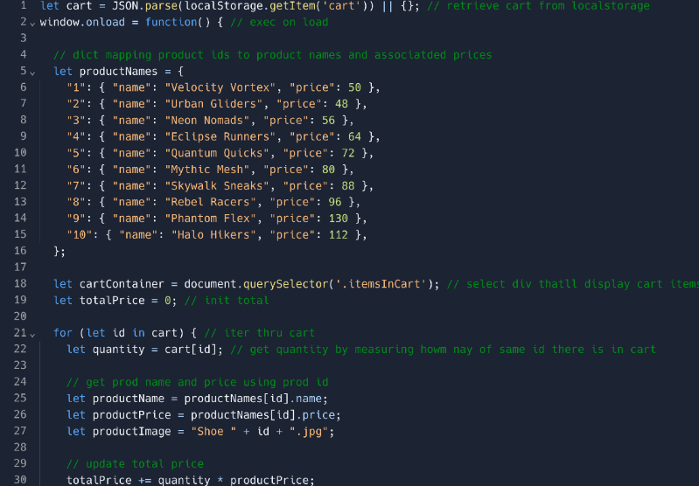Interactive features are included on the page to improve the purchasing experience. In order to receive savings and easily complete the checkout process, users can apply promo codes. The page also has a link to cart.js, a JavaScript file that has functionality for ordering and managing a shopping cart:

This small snippet of JS is the start of the Cart.js, and sets out the products that we sell, as well as prices, and then go on to display the items in the cart on the page, as well as details about it, such as name, price, image, and total price of the current cart. Referenced in the JS is the itemsInDiv cart, which can be seen below in Cart.html, where this is the div (HTML container) to display the items in the cart.

The initial value for total is £0.00. An input field for entering a voucher code and a button with the class "voucher" are provided by a nested "voucher" section inside this container. "product_button" to apply the coupon, triggering the "applyVoucher()" JavaScript function.

## Show Offer Homepage

This popup informs users about the additional 20% promotion for all items by using code “20OFF” at checkout, this comes after a 2 second delay to ensure that this is seen nearly immediately after visiting the page, bringing this to the user’s attention.

The 2 second delay here helps to ensure the user is not immediately bombarded with information, for instance seeing all the showcased shoes, as well as a popup immediately may be overwhelming, furthermore, the popup should only appear once the page has loaded; it is possible that only parts of the webpage have loaded up to 2 seconds, therefore this also helps with that potential issue.

The visited Boolean set to true is to ensure that the popup is only displayed one time per session, where the session end occurs as soon as the checkout button is triggered on the cart.html page, since in preliminary testing, without this, our test users felt it was a nuisance, since they had already been made aware of the discount code.

## Browser Object Model (BOM) and Document Object Model (DOM)

Use of methods such as addEventListener on buttons, as in internal JS in contact.html, has helped provide event-driven programming, where a function is triggered upon a button being pressed, this can be seen in the contact.html where a modal is displayed on screen informing the user that their feedback has been sent, but only once they have pressed the submit button.

Use of the DOM method getElementById in cart.js, provides a link from the front-end to the back end, which allows values fed into input boxes on the webpage then be manipulated in the JavaScript in the back end, this allows for discounts and prices to be calculated for the products added to the cart (products stored in the browser’s LocalStorage, using the WebStorage api).

Use of BOM methods such as window.onload, as in cart.js, allows for a given function to be run as soon as the page is loaded. This has been used in cart.js as when the page is loaded, a dictionary is made with all the product names, prices, and a unique identifier, which allows each product to later be manipulated, e.g. cumulative total of price. Furthermore, window.alert (shortened to alert()) has been used in order to provide the initial popup to the user, informing them of the (additional) 20% discount on all products when using the given code, this allows for the user’s attention to be immediately captured, as the popup occurs at a window level, which means the webpage cannot be used, until the user acknowledges the information within the popup. Furthermore, use of the window.location.reload method as part of BOM results in the webpage being reloaded upon a product being removed from the cart, which results in the cumulative price being recalculated, with the discount code being removed, but also removing from the used vouchers pair in LocalStorage vouchers key, which allows the user to reapply the discount code at the new price, now having removed a product.

# Conclusion and future works:

In conclusion, we believe that our website has fulfilled the purpose that was outlined in the introduction and the key features we wanted to implement have been implemented. Our website works as intended and all functionalities implemented have been tested and work, our website was also designed with efficiency in mind as we used the JPEG file format for images and SVG file format for the logo, this is to allow images to load faster and to save on client bandwidth. Our website is also user friendly, and we believe that the interface is intuitive and professional. However, we encountered some issues when creating our website, for example for our project we decided to collaborate via Replit, when writing code and attempting to see the changes within the website we would need to refresh the page multiple times until the change could be displayed which significantly increased our development time and it was stressful to collaborate on this platform due to conflicts. This was also our first time creating a CSS and we had difficulties with the positioning of certain elements and creating new CSS and testing it multiple times to ensure the positioning was correct was tedious and time-consuming, our website also works fully on mobile devices, but the positioning of certain elements needs to be improved as we developed our website mainly with desktop device resolutions and scaling in mind.

Even though we encountered some challenges, for e.g. limitations with the checkout function and login authentication we have tried our best to make significant progress in addressing these issues. Although the checkout function is not fully functional, due to the lack of a back end, we have realised these issues exist and plan to make them better for future iterations. To improve our website in the future we could begin to implement searching functionality allowing the users to easily find the shoe they want to purchase we should also add additional pages for each shoe providing detailed information about the shoe and allowing users to choose their shoe size and the styling they want for their shoe. Overall, the current iteration of our website is a success and future development will allow us to polish and fully deploy our website. Our login authentication system could also be improved, and we could encrypt and store user credentials within a database allowing users to login and retain their previous session, as part of improving the login functionality we can also implement a signing up system allowing customers to create accounts for themselves.

# References

[HTML Tutorial (w3schools.com)](https://www.w3schools.com/html/default.asp)

[JavaScript Tutorial (w3schools.com)](https://www.w3schools.com/js/default.asp)

[CSS Tutorial (w3schools.com)](https://www.w3schools.com/css/default.asp)